**YAHOO FINANCE**

Yahoo Finance is a comprehensive financial platform offering a wide range of features. It provides users with access to real-time stock quotes, news, and analysis for a variety of financial instruments. Users can track their investment portfolios, create watchlists, and view interactive charts. The platform also offers tools for screening and comparing stocks, as well as educational resources for investors. Yahoo Finance is known for its user-friendly interface and is a popular choice among investors and traders for staying informed about the latest market developments.

**SUMMARY OF THE COMPANY**

* We can check the summary of the company by either searching for company name or ticker symbol by following steps:
* In the search bar at the top of the page, type the name or ticker symbol of the company you are interested in.
* Press Enter or click on the search icon.
* From the search results, click on the correct company name or ticker symbol to go to its stock page.
* The company’s stock page will open with the summary section displayed by default.
* The summary section provides key financial metrics and information about the stock.

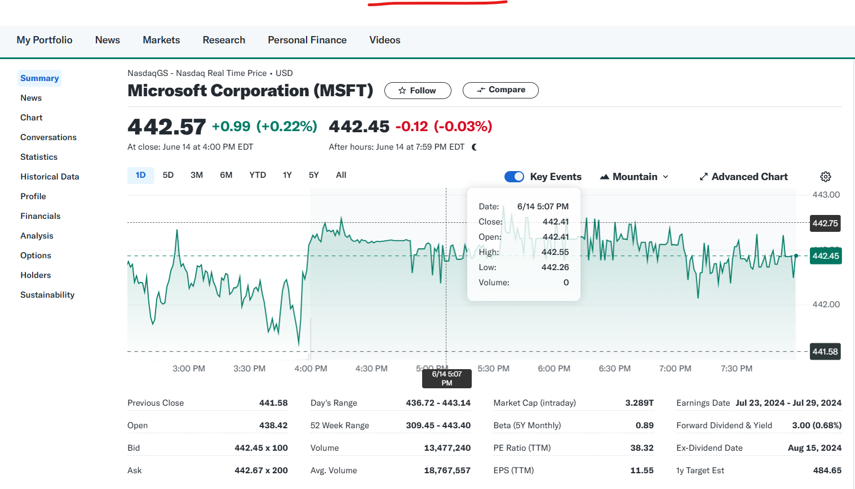

* Here is what you will typically find in the summary section:
* **Previous Close**: The last trading price of the stock on the previous trading day.
* **Open**: The price at which the stock started trading on the current day.
* **Bid**: The highest price a buyer is willing to pay for the stock.
* **Ask**: The lowest price a seller is willing to accept for the stock.
* **Day's Range**: The lowest and highest prices at which the stock has traded during the current trading day.
* **52 Week Range**: The lowest and highest prices at which the stock has traded over the past 52 weeks.
* **Volume**: The total number of shares traded during the current trading day.
* **Avg. Volume**: The average number of shares traded per day over a specified period (typically 30 days).
* **Market Cap**: The total market value of the company’s outstanding shares.
* **Beta**: A measure of the stock's volatility relative to the overall market.
* **PE Ratio (TTM)**: The price-to-earnings ratio calculated using the trailing twelve months earnings used to evaluate the valuation of a company's stock.

1. **Trailing P/E Ratio=**

**Current Stock Price / Earnings per Share (EPS) for the trailing 12 months**

1. **Current Stock Price**: The current market price per share of the company's stock.
2. **Earnings per Share (EPS)**: The total earnings of the company divided by the number of outstanding shares over the last 12 months.
3. **High P/E Ratio**: May indicate that the stock is overvalued or that investors expect high growth rates in the future.
4. **Low P/E Ratio**: May indicate that the stock is undervalued or that the company is experiencing difficulties.

* **EPS (TTM)**: Earnings per share over the trailing twelve months. It Indicates the company's profitability on a per-share basis.
* **Earnings Date**: The date on which the company is scheduled to release its next earnings report. Earnings reports can significantly impact the stock price, and investors often look forward to these dates.
* **Forward Dividend & Yield**: The total annual dividend expected to be paid per share and the dividend yield.
* **Ex-Dividend Date**: The cutoff date to be eligible for the next dividend payment. Investors need to own the stock before this date to receive the upcoming dividend.
* **1y Target Est**: The average price target estimated by analysts for the stock over the next year. Provides an expectation of the stock’s future price based on analysts’ forecasts.

**STOCK ANALYSIS**

To track the Stocks details such as stock gainers, losers and trending stocks we go to market section from the yahoo finance navigation bar.

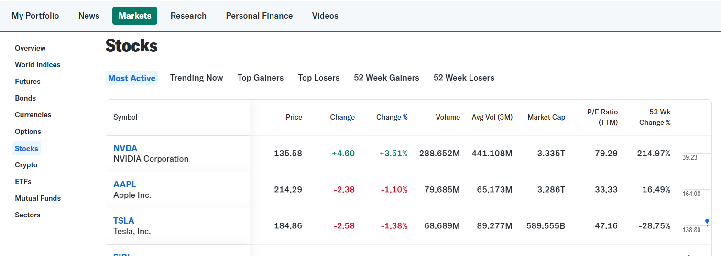

The market section also provides various information on various aspects as shown in the sidebar such as currencies information, bonds, cryptos and many more.

**CHART ANALYSIS**

We can also analyse the charts of various companies and tickers and can also customize them according to our needs.

1. Use the search bar at the top of the page to look for the stock we want to chart. We can enter the stock symbol or the company name.
2. On the stock's overview page, look for the "Chart" tab near the top of the page, next to "Summary," "Performance," etc. Click on the "Chart" tab.
3. Yahoo Finance provides various options to customize the chart. We can change the time frame (e.g., 1 day, 5 days, 1 month, etc.), chart type (line, candlestick, bar), and add technical indicators (e.g., moving averages, MACD, RSI) from the toolbar above the chart.
4. Beneath the chart, we can find additional data such as volume, market cap, and other key statistics for the selected stock.

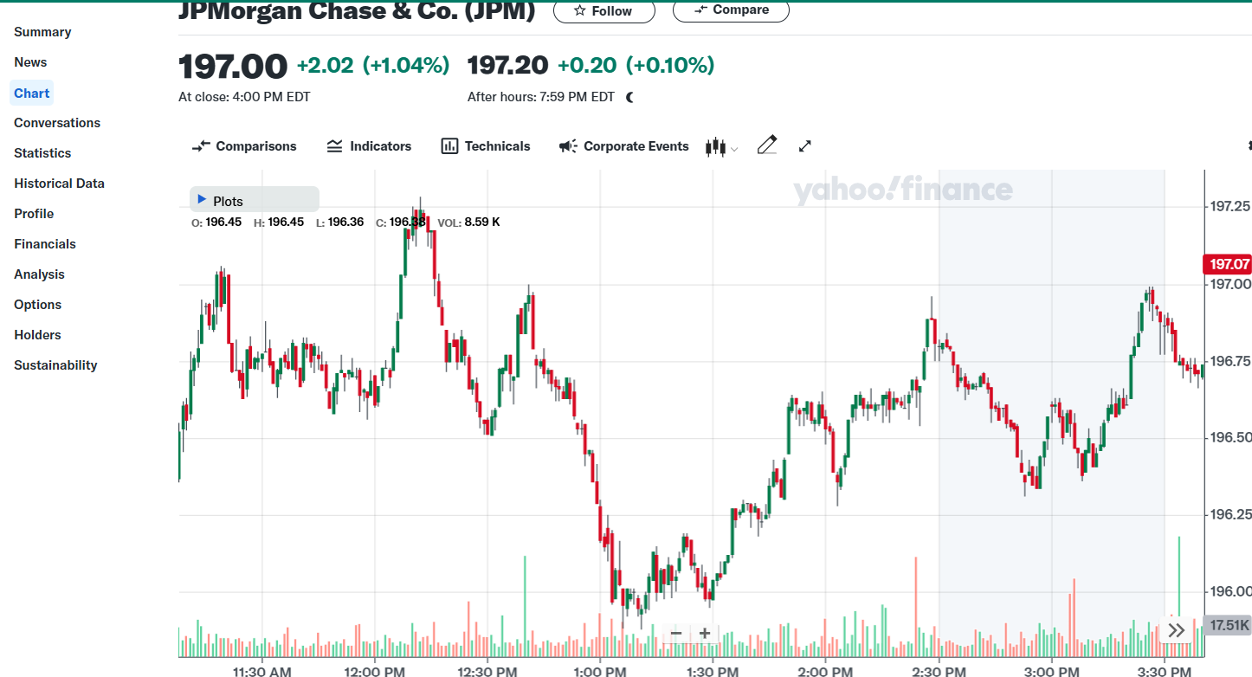

* We can also compare stocks of different companies on a single chart as shown in the image.

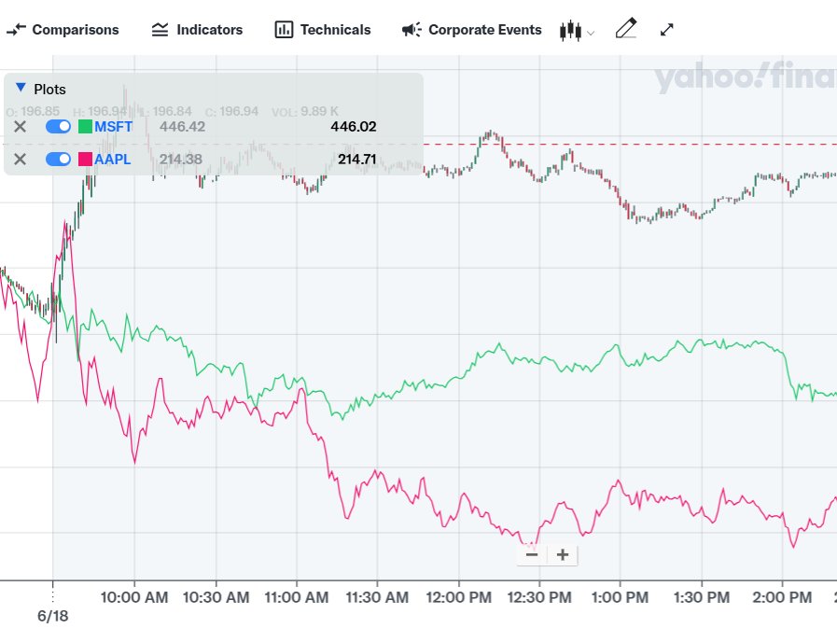

* It shows the comparison between JPMorgan Chase&Co. and Microsoft and Apple.
* We can also have various tools to understand the charts better by going to draw section of the chart.

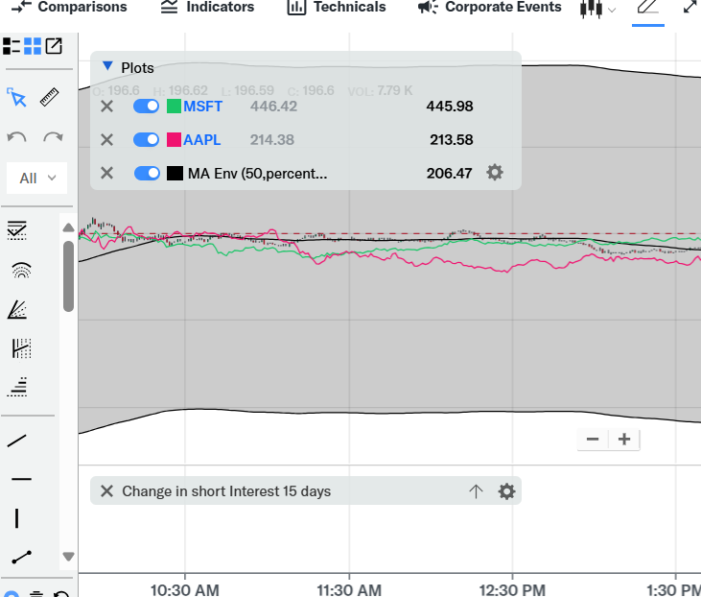

* We can also get the information of various Major holders, top institutional Holders and Top mutual Fund Holders of the Stocks by going to Holder section in the market tab.

